Fraud Detection Deployment Architecture

A continuous machine learning (ML) model, often referred to as continuous training, involves setting up a system that automatically updates and improves the model over time as new data becomes available:

# Deployment Workflow

### Model

* A Machine learning model is trained. The model is then stored and loaded using joblib

### Application

* Flask application handling csv uploads.
* Process the uploads using pandas
* Makes predictions on the data
* Verifies the predictions (human interaction)
* Logging all data

### Frontend

* Simple HTML templates with CSS styling

### Functionality

* Upload files
* Predict fraud
* Verify fraudulent transitions
* Log results
* Return to upload

# 

# Architecture

**Client Layer:** Web browser where files can be uploaded.

**Application Laye**r: Flask App servicing the front end and handling logic

**Model Serving Layer**: Dedicated service or module for model inference

**Data Storage Layer**: Persistent storage for transaction_logs and model file

**Infrastructure Layer**: Hosting on cloud platform (AWS, Google Cloud, Render)

### Flow Diagram

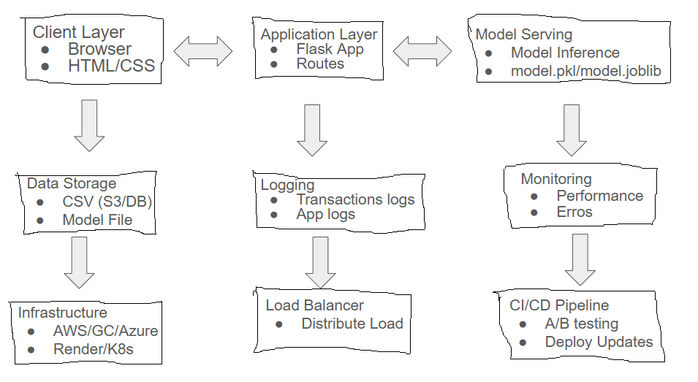

### Retraining

The application will prompt for retraining when there are a certain number of entries in the log-file. The retrained model will then be A/B tested and redeployed if it performs better than the previous model.

… Model in Service